**EARLY FLOOD DETECTION SYSTEM USING ARDUINO**

A Capstone Project Proposal

Presented to the Faculty of the

College of Computer Studies and Information Technology,

Southern Leyte State University-Tomas Oppus Campus

In Partial Fulfillment of the Requirement

For the Degree of Bachelor of Science in Information Technology

By:

**Malakit L. Ram**

**Christian Jay Varquez**

**Percival Velos**

**Emma Bandibas**

September 2023

**APPROVAL SHEET**

This Research/Capstone Project Study entitled “___________________________________” prepared and submitted by ____________, _____________, and ____________ has been examined and is recommended for approval and acceptance.

**APPROVED** by the Committee on Oral Examination with a grade of ____________ on ________________.

**DORRIS S. LINTAO, MSTCS** **JOSE C. AGOYLO JR., MSIT**

ADVISER IT EXPERT

**FELANIE DOCENA**  **ENGR. EFREN I. BALABA, PhD.TM**

MEMBER PANEL CHAIR

**__________** and **______________** in partial fulfillment of the requirements in Bachelor of Science in Information Technology.

**ENGR. EFREN I. BALABA, PhD.TM**

Department Head, BSIT

Date: ___________________

**Table of Contents**

**Page**

Title Page i

Table of Contents ii

List of Figures iii

**Chapter I: Introduction**

Project Context 1

Purpose and Description of the Project 1

Objectives of the Project . 2

Scope and Limitations of the Project .. 2

**Chapter II: Review of Related Literature**

Review of Related Literature and Studies 4

**Chapter III: Technical Background**

1. The Technicality of the Project 5
2. Details of the Technology to be used 5-7
3. Proposed Project Plan 7-9
4. Architectural Layout 10-11

**REFERENCES** 12

**BIBLIOGRAPHY**

**APPENDICES**

**CURRICULUM VITAE**

**List of Figures**

1. Arduino 13
2. Waterflow Sensor 13
3. Rainfall Sensor 14
4. Water level sensor 14
5. GSM Module 15
6. Architectural Layout: Use case diagram 20
7. Architectural layout 21

**Chapter I**

**Introduction**

**Project Context**

River flooding is a complex and widespread phenomenon that occurs when a river's water level exceeds its banks, inundating the surrounding areas. This natural event can have devastating consequences for both human communities and the environment.

Baranggay Rizal, Tomas Oppus Southern Leyte is a community that has been grappling with a persistent and pressing issue - flooding. Situated in a flood-prone area primarily due to its proximity to a river, the residents of this barangay have been enduring the devastating consequences of recurrent floods. The impact of these floods extends beyond the mere inconvenience of waterlogged streets; it poses a significant threat to the well-being of its residents, damages property, and jeopardizes critical infrastructure.

This natural calamity is unavoidable, but with an early warning system and quick response, the damage can be minimized. One way that could considerably reduce the impact of losses is forecasting and warning systems. It is critical to alert or warn the public about an impending disaster in the early stages so that safety precautions can be taken to avoid unintended consequences. The early warning system must be capable of providing timely warning of impending threats, allowing local authorities to prepare for an effective response.

This research focuses on a flood disaster monitoring system that can assist local government in providing a more systematic solution. The technology is meant to detect floods and provide continual alerts or information. The information of water level can be detected by the sensors. The different sensors measure the various environmental and weather-related parameters and monitor them constantly. The system that will be develop utilizes GSM and SMS to transmit data from sensors to the respective users through their mobile phone. By using GSM module, GSM network can be used since it is much more accountable during flood season.

The development of early flood detection system is vital for protecting lives, property, infrastructure, and the environment. These systems contribute to disaster preparedness, risk reduction, and more effective responses to flood events, ultimately enhancing the resilience of communities in the face of natural disasters.

**Purpose and Description of the Project**

Smart Detection System is an early flood detection system is a specialized system or network of devices and sensors designed to monitor environmental conditions and detect the early warning signs of potential flooding in a specific area. Its main purpose is to provide advance notice and alerts to authorities and communities, enabling them to take timely action to mitigate the effects of a flood.

The primary purpose is to provide early warnings about potential flooding events. By detecting rising water levels, heavy rainfall, or other indicators in advance, these systems enable authorities to issue timely alerts to affected areas, giving people more time to prepare and evacuate if necessary.

Early flood detection systems aim to reduce the risk of property damage, injury, and loss of life. By providing advance notice, individuals and communities can take preventive measures such as moving valuable items to higher ground, reinforcing flood defenses, and evacuating vulnerable areas.

**Objectives of the Project**

The main objectives of the proposed system are as follows:

Objectives of the Project

* To provide early warnings to local authorities and residents about potential flooding events, enabling them to take proactive measures to minimize damage and ensure safety.
* To gather real-time data on water levels, water flow, rainfall, and weather conditions to monitor flood and predict potential flood events accurately.
* To create user-friendly interfaces and data visualization tools to display real-time information to the public and decision-makers, making it easier to understand the flood situation.
* To integrate the Arduino-based system with existing early warning systems and communication channels for seamless dissemination of alerts.

**Scope and Limitations of the Project**

**Scope**

The scope of this research is to develop and evaluate an early flood detection system using Arduino sensors. The system will be detecting if there is a possible flood that will occur. The system will be evaluated in a real-world setting to assess its accuracy and efficiency.

**Limitations**

This system has its own limitations the Arduino-based system may require regular maintenance, and their long-term reliability should be considered. Factors like sensor calibration and battery life may impact the system's performance.

The speed of flood detection and alerting may be influenced by the system's hardware and data processing capabilities.

The project may be limited by budget constraints, affecting the choice of sensors, communication modules, and other components.

Also, compliance with local regulations and ethical considerations related to data privacy and community engagement should be addressed.

**Chapter II**

**Review of Related Literature**

Edwin De Guzman et al. proposed the system to improve and plan a flood identification framework that will identify the flood automatically and send information to the Local Government Unit and to area residents using an Arduino.

Amol Ratho et al. represents the design and implementation of flood detection system by using barometric pressure sensor. The designed monitoring system effectively sends the message to the recipient when water crosses the edge level. The designed monitoring system framework is less expensive, dependable and quick that is the reason this observing system is useful to avoid the harm of properties and loss of lives.

J G Natividad et al. proposed a system to produce a flood monitoring system that observer the water level of the rivers by the use of sensors and to design and develop an early warning system. In this study forms a model system that detects the current water level across the watershed of Cagayan River and its surrounding areas through ultrasonic sensors.

**Chapter III**

**Technical Background**

1. **The Technicality of the Project**

The project Early flood detection system is essential for saving our lives. The implementation of early flood detection system is necessary to those people near in the river.Early detection of floods is proposed in this study that incorporates sensor devices to warn the residence. With the aid of sensors, the water level will be identified and the rain intensity. Sensors and the IoT module are connected through a microcontroller.

Effective flood detection often involves the integration of multiple data sources and technologies to provide accurate and timely information. Early warning systems play a crucial role in alerting authorities and communities to potential flood events, allowing for proactive measures and evacuation plans to be put in place to mitigate the impact of flooding.

1. **Details of the Technologies to be used**
2. A close-up of a blue circuit board

   Description automatically generated***Arduino:***Arduino is an open-source electronics platform and a family of microcontroller boards and software tools that are commonly used for creating interactive electronic projects.

Figure 1.

1. ***Water Flow Sensor:*** Water flow sensors are installed at the water source or pipes to measure the rate of flow of water and calculate the amount of water flowed through the pipe. Rate of flow of water is measured as liters per hour or cubic meters.

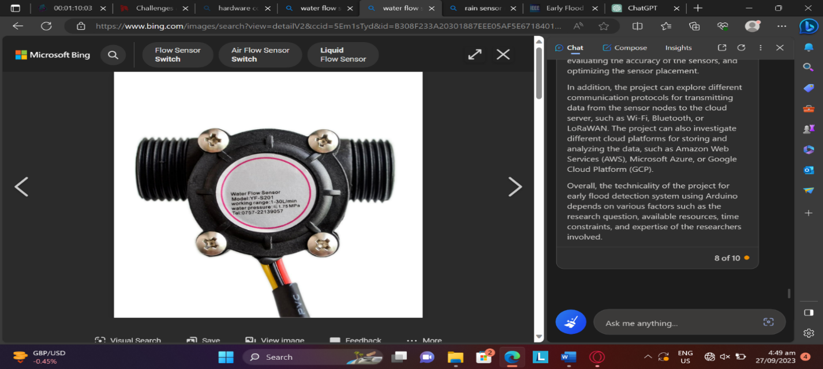

Figure 2

1. ***Rainfall Sensor:*** A rain sensor, also known as a rain detector or rain gauge, is a device or sensor designed to detect the presence or intensity of rain or precipitation.

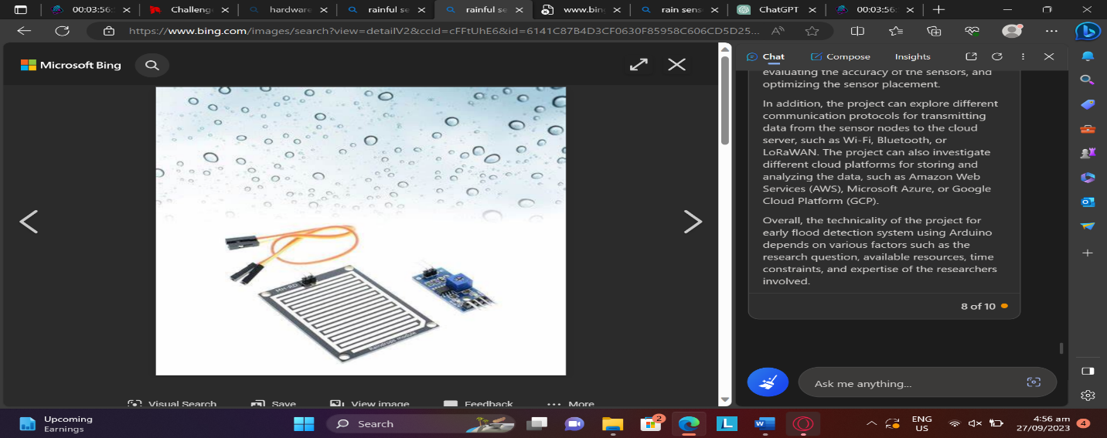

Figure 3

1. Water Level Sensor: Water level sensor is a device or instrument specifically designed to measure and monitor the water level at a particular point along the river's course.

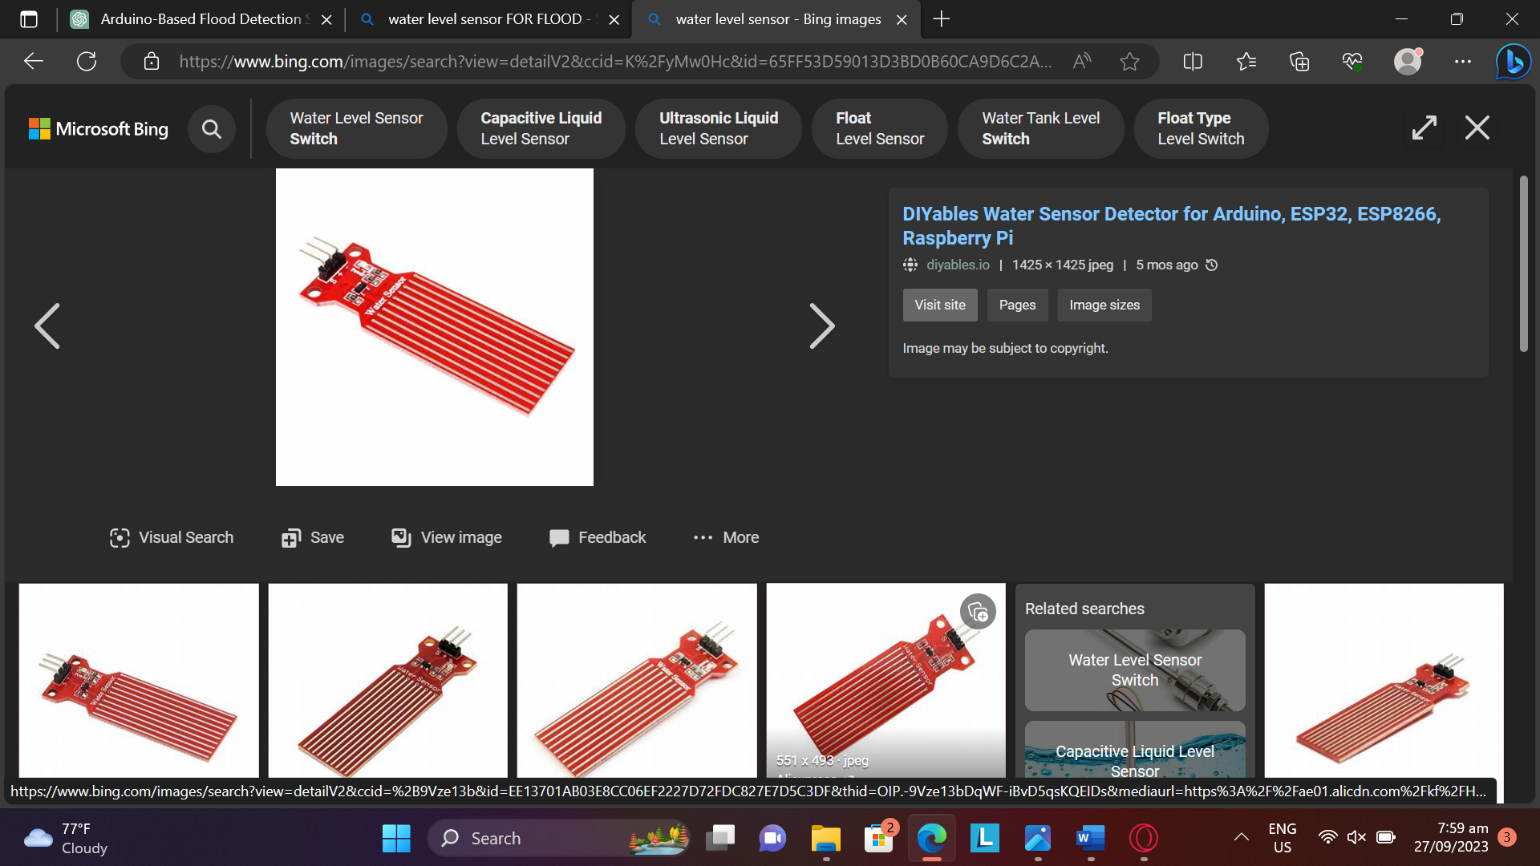

Figure 4

1. ***GSM Module****:* GSM is a widely used standard for cellular communication, and GSM modules allow devices to send and receive data, including text messages (SMS).

Figure 5

**Proposed Project Plan**

**Phase 1: Project Initiation (Week 1-2)**

1.1. Project Definition and Scope

* Define the project's objectives and scope.
* Identify key stakeholders, including the residence of the barangay.

1.2. Project Planning

* Develop a detailed project plan, including a timeline, budget, and resource allocation.
* Establish the project team and assign roles and responsibilities.

1.3. Feasibility Study

* Assess the feasibility of implementing the Early Flood Detection System
* Identify potential challenges and risks.

**Phase 2: Research and Data Collection (Week 3-6)**

2.1. Literature Review

* Conduct an extensive review of existing studies and technologies related to flood detection.
* Identify relevant approaches used in detecting flood.

2.2. Data Collection

* Gathering data to baranggay Rizal, Tomas Oppus including the situation of recurrent flood.
* Collect information of those residence near in the river.

**Phase 3: System Design and Development (Week 7-9)**

3.1. Hardware Design

* Design flood detection hardware, including the Arduino-based sensors, water flow sensors, rainfall sensor and water level sensors.

3.2. Software Development

* Develop the software interface for monitoring and managing the early flood detection.
* Create a user-friendly Android application for flood detection for user.

**Phase 4: Testing and Deployment (Week 10-12)**

4.1. Prototype Testing

* Test the Early Flood Detection System to ensure accurate data of flood situation.

4.2. Real-World Deployment

* Deploy the Early Flood Detection System at strategic locations within baranggay Rizal, Tomas Oppus.
* Educate the residence about the information of flood results.

**Phase 5: Monitoring and Evaluation (Week 13- 14)**

5.1. Data Collection and Analysis

* Collect real-world data on mitigating flood and system performance.
* Analyze the collected data to assess the accuracy and efficiency of early flood detection warning.

5.2. User Feedback

* Gather feedback from users, including residence near in the river to identify any issues or improvements needed.

**Phase 6: Documentation and Reporting (Week 15-16)**

6.1. Final Report

* Compile all project documentation, including design specifications, testing results, and user feedback.
* Prepare a final project report detailing the entire development process.

6.2. Presentation

* Create a presentation summarizing the project's goals, achievements, and benefits.
* Present the project to baranggay officials and the residence.

**Phase 7: Project Completion and Handover (Week 17)**

7.1. Project Handover

* Hand over the flood detection in baranggay Rizal, Tomas Oppus Campus for continued operation and maintenance.

7.2. Maintenance and Support

* Provide ongoing support and maintenance as needed.

**Phase 8: Project Evaluation and Lessons Learned (Week 18)**

8.1. Evaluation

* Conduct a final evaluation to measure the long-term impact of the early flood detection system.

8.2. Lessons Learned

* Document lessons learned throughout the project, including challenges faced and successful strategies.

1. **Architectural Layout**

Use Case Diagram

Figure 6

**ARCHITECTURAL LAYOUT**

Figure 7

**References**

Simatupang, J. W., & Naufal, F. (2019). Flood Early Warning Detection System Prototype Based on IoT Network. Internetworking Indonesia Journal, 11(1), 17-22. [(internetworkingindonesia.org)](https://internetworkingindonesia.org/Issues/Vol11-No1-2019/iij_vol11_no1_2019_simatupang.pdf)

Megha, G., Babasaheb, D. P., Manojkumar, S., & Akshay, D. (2019). Early Flood Detection System using Android Application. International Journal of Engineering Research & Technology, 8(7).

[Early Flood Detection System using Android Application (ijert.org)](https://www.ijert.org/research/early-flood-detection-system-using-android-application-IJERTV8IS070260.pdf)

Roy, M., Pradhan, P., George, J., & Pradhan, N. (2020). Flood Detection and water Monitoring system using IoT. International Journal Of Engineering And Computer Science, 9(07), 25113-25115.

[(PDF) Flood Detection and Water Monitoring System Using IOT (researchgate.net)](https://www.researchgate.net/publication/342691536_Flood_Detection_and_Water_Monitoring_System_Using_IOT)

Shankar, B. M., John, T. J., Karthick, S., Pattanaik, B., Pattnaik, M., & Karthikeyan, S. (2021). Internet of Things based Smart Flood forecasting and Early Warning System. 2021 5th International Conference on Computing Methodologies and Communication (ICCMC). doi:10.1109/iccmc51019.2021.94183

[Dinesh, D., & Regina, I. A. (2019). Prediction and Effective Monitoring of Flood Using Arduino System Controller and ESP8266 Wi-Fi Module. International Journal of Communication and Networking System, 8(01), 50-55. - Search (bing.com)](https://www.bing.com/search?pglt=41&q=Dinesh%2C+D.%2C+%26+Regina%2C+I.+A.+(2019).+Prediction+and+Effective+Monitoring+of+Flood+Using+Arduino+System+Controller+and+ESP8266+Wi-Fi+Module.+International+Journal+of+Communication+and+Networking+System%2C+8(01)%2C+50-55.&cvid=4f0bbba29843403e988eb97fa0c73bf5&aqs=edge..69i57j69i60.895j0j1&FORM=ANNTA1&PC=LCTS)

Nasution, T. H., Siagian, E. C., Tanjung, K., & Soeharwinto. (2018). Design of river height and speed monitoring system by using Arduino. IOP Conference Series: Materials Science and Engineering, 308, 012031. doi:10.1088/1757-899x/308/1/012031

[Design of river height and speed monitoring system by using Arduino - IOPscience](https://iopscience.iop.org/article/10.1088/1757-899X/308/1/012031)

Yuliandoko, H., Subono, Wardhany, V. A., Pramono, S. H., & Siwindarto, P. (2017). Design of flooding detection system based on velocity and water level DAM with ESP8266. 2017 2nd International Conferences on Information Technology, Information Systems and Electrical Engineering (ICITISEE). doi:10.1109/icitisee.2017.8285537

[A-Novel-Approach-for-a-Smart-Early-Flood-Detection-and-Awareness-System-using-IoT.pdf (researchgate.net)](https://www.researchgate.net/profile/Jrarunkumar-Kumar/publication/361038488_A_Novel_Approach_for_a_Smart_Early_Flood_Detection_and_Awareness_System_using_IoT/links/633ebb50ff870c55ce067029/A-Novel-Approach-for-a-Smart-Early-Flood-Detection-and-Awareness-System-using-IoT.pdf)

S. Miau and W.-H. Hung, “River Flooding Forecasting

and Anomaly Detection Based on Deep Learning,” IEEE

Access, vol. 8, pp. 198384–198402, 2020.

S. Miau and W.-H. Hung, “River Flooding Forecasting

and Anomaly Detection Based on Deep Learning,” IEEE

Access, vol. 8, pp. 198384–198402, 2020.

Landuyt, L., Van Wesemael, A., Schumann, G. J.-P., Hostache, R., Verhoest, N. E. C., & Van Coillie, F. M. B. (2018). *Flood Mapping Based on Synthetic Aperture Radar: An Assessment of Established Approaches. IEEE Transactions on Geoscience and Remote Sensing, 1–18.* doi:10.1109/tgrs.2018.2860054